Crazy Train

1. Find hidden field in new article form

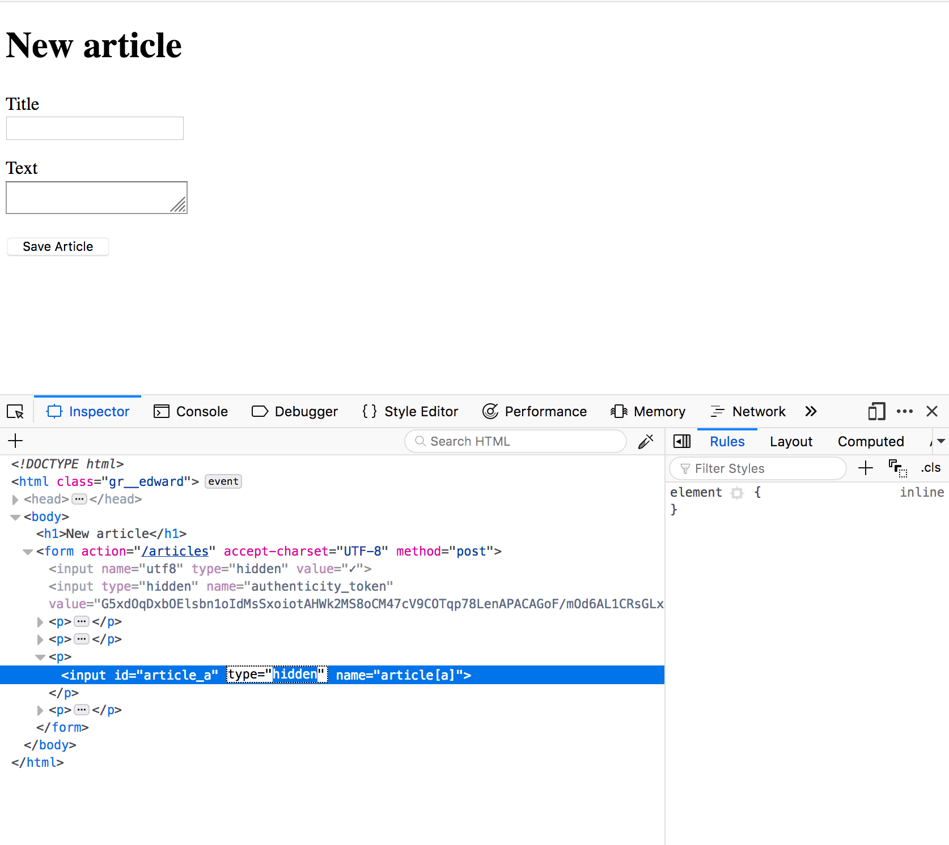

1. Realize that it’s being eval’d by the server

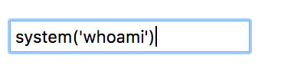

1. Exfiltrate the data to a remote server.
2. Cat the flag.txt